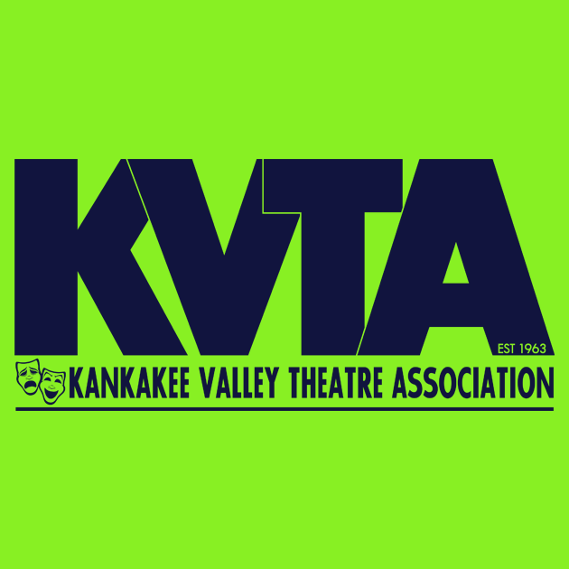

March 15, 2018

Dear Friend of KVTA:

KVTA is now accepting applications for Directors for the 2018-2019 season. Digital scripts are available for perusal. Interested parties should contact Robin Tober-Betourne at rtob35@yahoo.com to obtain a digital copy of the script(s) they wish to read.

2018-2019 PRODUCTIONS – PLEASE NOTE: All dates are TENTATIVE and cannot be confirmed until the Dist. 111 calendar is finalized, so dates could possibly change (but would be in the same general time frame).

- KVT: Newsies – Sept. 29 & 30 and Oct. 6 & 7, 2018 at LCC
- YPT: June B. Jones, Jr. – November 15, 16, 17, & 18, 2018 at LCC
- KVT: Little Women – February 8, 9, 10, 15, 16, & 17, 2019 at the KVTA Studios
- YPT: Narnia– April 4, 5, 6, & 7, 2019 at LCC

Director applications must be submitted digitally to Robin at rtob35@yahoo.com. To be considered, you must EMAIL your application ON OR BEFORE APRIL 13, 2018. After the deadline date, all applicants will receive an interview time for April 15, 2018. Interviews will begin at 4:30 p.m. and will be held at the KVTA Studios. Interviews usually last about 15-20 minutes.

IMPORTANT NOTES PLEASE READ:

- The Kankakee Valley Theatre Association’s Board of Directors reserves the right to not select an individual for the position of Director for any given show from the applications received. If no decision is reached for a specific show, the application process may be reopened or a new show selected.
- Director Eligibility: In order to be eligible to direct a KVTA production, an individual must have previously served in at least one of the following capacities for KVTA: director, assistant director, vocal director, choreographer, stage manager, production coordinator/board liaison, or performed in a minimum of five (5) KVTA productions.
- Anyone applying to direct must be willing to make changes in the script, set, etc. if the KVTA board deems it necessary.
- KVTA participates in many festivals, farmers’ markets, parades, promo events, etc. throughout the year. We expect our directors and their staff members to help work these events to advertise the season.
- FYI: For select shows, KVTA could decide to use a performance track for the orchestration instead of a live orchestra.
- In addition to cast members, all directors and paid staff members must become a paid member at some level before the start of their show.
- Any of the shows listed above may be changed at any time by the KVTA Board or the licensing company due to licensing issues, venue changes, school conflicts, etc. If a show is changed, applications for directors for the new show would start all over. The individual who was selected to direct a show that is changed would also have to reapply for the new show.

Please feel free to contact any KVTA board member if you have any questions.

Respectfully,

The Board of Directors of Kankakee Valley Theatre Association

Not just a stage in your life . . .

